IET DEPARTMENT



Data Structure and Algorithm
Lab Manual

Lab 7: Stack Data Structure

Objectives:
- Stack
- Stack using Linked List Concept
- Stack using Array Concept

Introduction
Suppose that you have a program with several functions. To be specific, suppose that you have the functions A, B, C, and D in your program. Now suppose that function A calls function B, function B calls function C, and function C calls function D. When function D terminates, control goes back to function C; when function C terminates, control goes back to function B; and when function B terminates, control goes back to function A. During program execution, how do you think the computer keeps track of the function calls? What about recursive functions? How does the computer keep track of the recursive calls?
This section discusses the data structure called the stack, which the computer uses to implement function calls. You can also use stacks to convert recursive algorithms into non recursive algorithms, especially recursive algorithms that are not tail recursive. Stacks have numerous other applications in computer science. After developing the tools necessary to implement a stack, we will examine some applications of stacks.
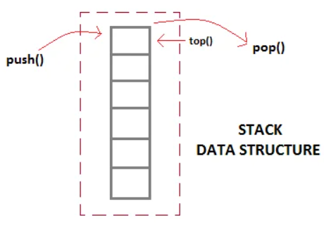
Stack data structure(LIFO)
Concept Map
Stack (LIFO)
A stack is a list of homogenous elements in which the addition and deletion of elements occurs only at one end, called the top of the stack. The elements at the bottom of the stack have been in the stack the longest. The top element of the stack is the last element added to the stack. Because the elements are added and removed from one end (that is, the top), it follows that the item that is added last will be removed first. For this reason, a stack is also called a Last In First Out (LIFO) data structure.
Push () and Pop() working: The push, top, and pop operations work as follows: Suppose there are boxes lying on the floor that need to be stacked on a table. Initially, all of the boxes are on the floor and the stack is empty.
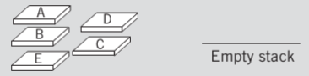

Different push and pop will make this stack looks as:

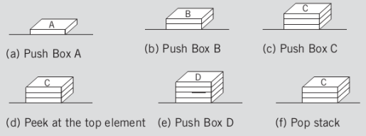

Stack Using Link List:
Stacks can be easily implemented using a linked list. Stack is a data structure to which a data can be added using the push() method and data can be removed from it using the pop() method. With Linked list, the push operation can be replaced by the addAtFront() method of linked list and pop operation can be replaced by a function which deletes the front node of the linked list. In this way our Linked list will virtually become a Stack with push() and pop() methods.
I n the above example, the last inserted node is 99 and the first inserted node is 25. The order of elements inserted is 25, 32,50 and 99.
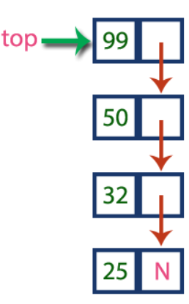

Sample Program:
import static java.lang.System.exit;
// Create Stack Using Linked list
class StackUsingLinkedlist {

// A linked list node
private class Node {

int data; // integer data
Node link; // reference variable Node type
}
// create global top reference variable global
Node top;
// Constructor
StackUsingLinkedlist() { this.top = null; }

// Utility function to add an element x in the stack
public void push(int x) // insert at the beginning
{
// create new node temp and allocate memory
Node temp = new Node();

// check if stack (heap) is full. Then inserting an
// element would lead to stack overflow
if (top == null) {
temp.data = x;
top = temp;
return;
}
else{
// initialize data into temp data field
temp.data = x;
// put top reference into temp link
temp.link = top;
// update top reference
top = temp;
}
}

// Utility function to check if the stack is empty or
// not
public boolean isEmpty() {
if (top == null)
System.out.println("Yes, Stack is empty");
return top == null;
}

// Utility function to return top element in a stack
public int peek()
{
// check for empty stack
if (!isEmpty()) {
return top.data;
}
else {
System.out.println("Stack is empty");
return -1;
}
}

// Utility function to pop top element from the stack
public void pop() // remove at the beginning
{
// check for stack underflow
if (top == null) {
System.out.print("\nStack Underflow");
return;
}

// update the top pointer to point to the next node
top = top.link;
}

public void display()
{
// check for stack underflow
if (top == null) {
System.out.printf("\nStack Underflow");
exit(1);
}
else {
Node temp = top;
while (temp != null) {

// print node data
System.out.print(temp.data);

// assign temp link to temp
temp = temp.link;
if(temp != null)
System.out.print(" -> ");
}}}

Stack Using Arrays:
A stack data structure can be implemented using a one-dimensional array. But stack implemented using array stores only a fixed number of data values. This implementation is very simple. Just define a one dimensional array of specific size and insert or delete the values into that array by using LIFO principle with the help of a variable called 'top'. Initially, the top is set to -1. Whenever we want to insert a value into the stack, increment the top value by one and then insert. Whenever we want to delete a value from the stack, then delete the top value and decrement the top value by one.

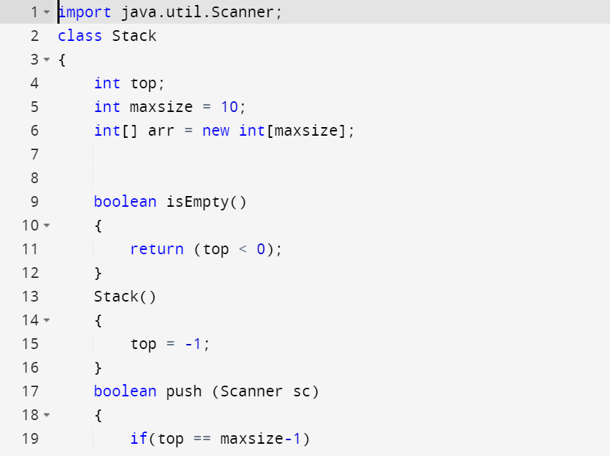
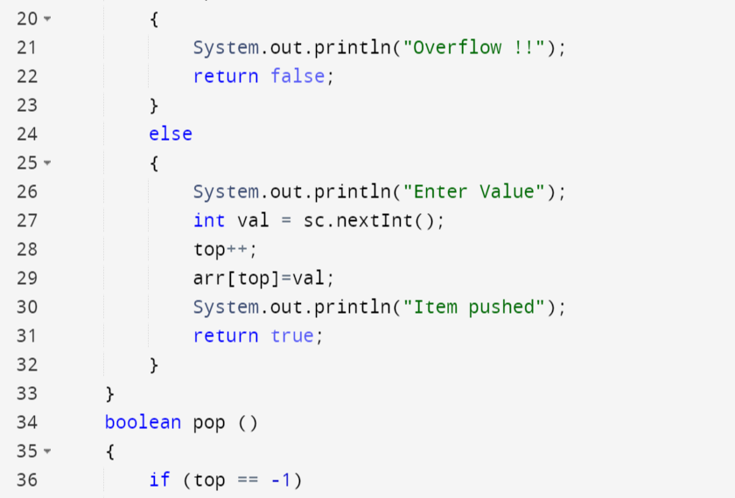
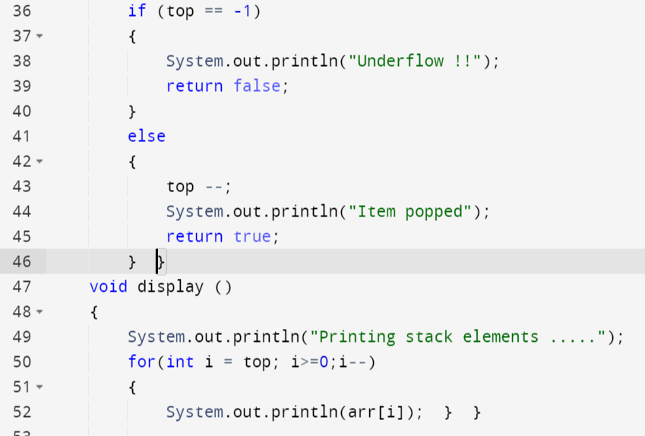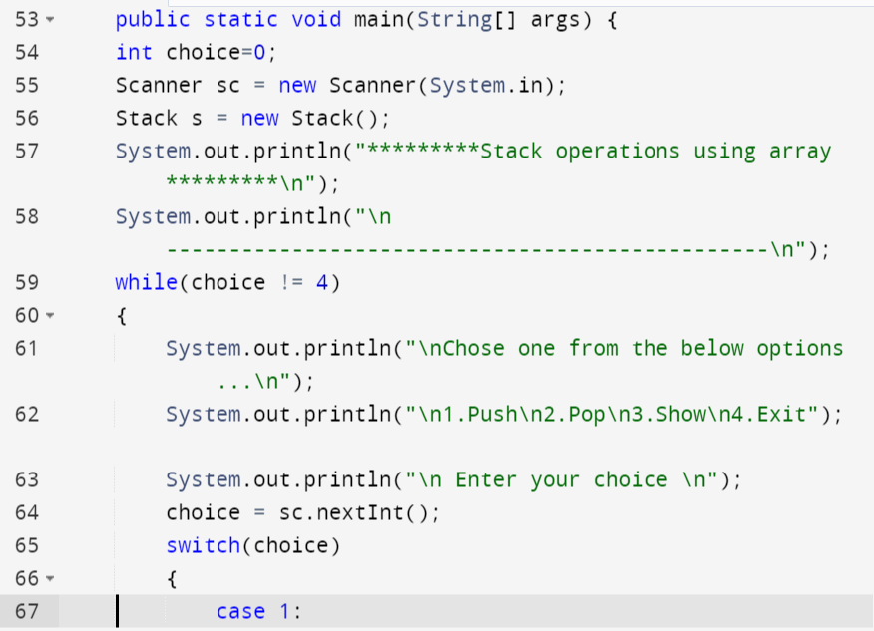
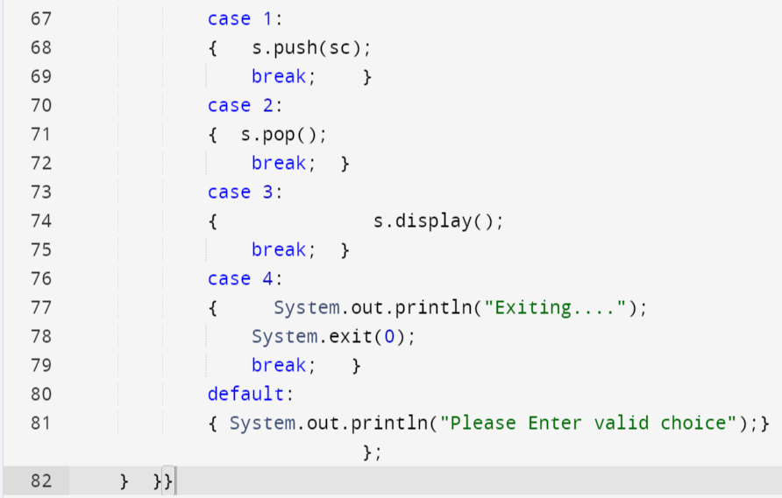

Practice Tasks
Lab Task 1:
Create a class Node for book that contains information about title, price, edition, and no of pages of the book. Implement your push, pop, peek books on a stack functions properly.
Now in the main:
1. Push 5 books into this stack.
2. Find the top element of the stack
3. Pop 2 books from the stack.
4. Display all the remaining books in the stack.

Evaluation criteria

The evaluation criteria for this lab will be based on the completion of the following tasks. Each task is assigned the marks percentage which will be evaluated by the instructor in the lab whether the student has finished the complete/partial task(s).

Further Reading
The slides and reading material can be accessed from the folder of the class instructor available at lms

Out comes
The outcomes of this lab were:
- Stack
- Stack using Linked List Concept
- Stack using Array Concept

